**Personas, Problem Scenarios and Propositions**

By Mousfiqul Islam Khan

1. Positioning Statement

NyGen (IT company, provides IT support to other businesses reducing their need to have an IT department for themselves). They have various clients from small firms to big corporations, providing either an extra assistance to any IT related issues, or sometimes they handle all of the IT related problems faced by the business.

* 1. Brainstorming Personas
     1. Todd the IT technician
     2. Diane the Sales Person
     3. Caroline the Admin Officer
  2. Details of a persona
     1. Todd the IT technician

Todd is an IT professional, he works at NyGen with the primary task of visiting various offices that have called for assistance. Companies may either want to build something new or need something fixed, and Todd’s job is to make an estimation of any projects that their clients are proposing, and also making estimations of a problem that needs to be fixed. In the case of an IT problem, if the problem is small, Todd and his team will fix it right away otherwise they will secure a date with a complete estimation of the cost of fixing the problem.

|  |  |
| --- | --- |
| Thinks | Todd would like to have access to all the documents that mention the prices of each parts and services so that he can make better estimation on site. |
| Sees | Todd sees that all the content for parts prices and service prices are in separate multiple platforms and are also missing sometimes. |
| Feels | Todd feels disappointed that whenever he tries to make an estimation he can’t find the most accurate details in one platform. |
| Does | Todd has to search on multiple platforms to find the price of parts and services, he has to sometimes have to make a phone call to the office to get more details when it isn’t available. |

* 1. Problem Scenario, Current Alternatives and Value Proposition

|  |  |  |
| --- | --- | --- |
| Problem Scenario | Current Alternatives | Value Proposition |
| Todd wants to be able to search for all prices and documentation from a single platform. | Currently he has to search in all platforms individually. | NyGen will provide a way to search for all documents. |
| Todd doesn’t want to put in his credentials in each platform every time he tries to find documents. | Currently Todd has to log in every time he has to look for prices to make his estimations. | NyGen will provide a way with which employees can search for all the content on a single platform. |

1. User Story

|  |  |
| --- | --- |
| Story | Test Cases |
| As an IT technician, I want to search by part names and service names. | Make sure it is possible to search for prices by part name.  Make sure it is possible to search for prices by service name. |
| As an IT technician, I want to be able to access all the information in a single platform. | Make sure the user have access to documentation on a single platform.  They have to log in to access the company information. |
| As an IT technician, I want to be able to log in just once and stay logged in. | Make sure the user has access and privilege on the platform.  If the validation checks out, make sure that the user stay logged in. |

1. Storyboard

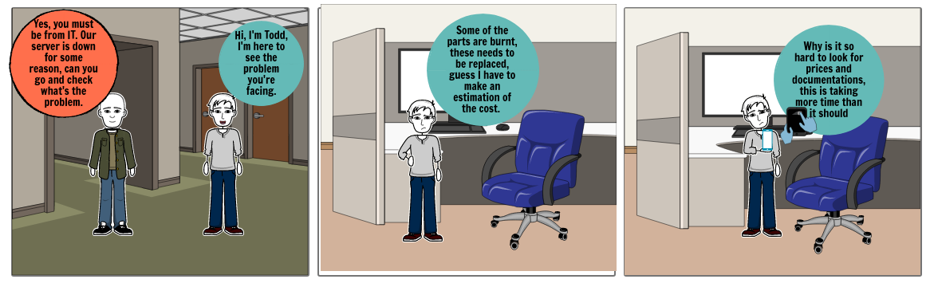

1. Child Stories and Test Cases

|  |  |
| --- | --- |
| Child Stories | Test Cases |
| As an IT technician, I should be able to filter the search according to price range to make an estimation best suited for the client. | Make sure it is possible to search for parts and services.  Make sure that the search results can be filtered according to price. |
| I would also want a mechanism which would enable the system to recommend good quality products at the top of the search result. | Make sure that the search result shows products that have higher recommendations at the top.  Make sure this result is constantly refined in case a better product comes to the market. |